MATHEMATICS METHODS

MAWA Semester 1 (Unit 3) Examination 2019
Calculator-assumed

Marking Key

© MAWA, 2019
Licence Agreement
This examination is Copyright but may be freely used within the school that purchases this licence.
- The items that are contained in this examination are to be used solely in the school for which they are purchased.
- They are not to be shared in any manner with a school which has not purchased their own licence.
- The items and the solutions/marking keys are to be kept confidentially and not copied or made available to anyone who is not a teacher at the school. Teachers may give feedback to students in the form of showing them how the work is marked but students are not to retain a copy of the paper or marking guide until the agreed release date stipulated in the purchasing agreement/licence.

The release date for this exam and marking scheme is 14th June.

Section Two: Calculator-assumed (100 Marks)

Question 8(a) (4 marks)
Solution
(i)
(ii) =
=
=
=
=
Mathematical behaviours | Marks
- states  - uses linearity and additivity to deduce  - anti-differentiates  - determines correct result of 16 | 1  1  1  1

Question 8(b) (3 marks)
Solution
=
=
=
=
Mathematical behaviours | Marks
- anti-differentiates correctly  - substitutes limits of integration correctly  - determines exact result | 1  1  1

Question 9(a) (1 mark)
Solution
Mathematical behaviours | Mark
- states justifies answer using anti-differentiation | 1

Question 9(b) (1 mark)
Solution
For stationary points,
Mathematical behaviours | Marks
- states coordinates of stationary points | 1

Question 9(c) (3 marks)
Solution
and
Hence there is a change in concavity at and so there is a horizontal point of inflection at . Hence m = 1.
Mathematical behaviours | Marks
- states and  - demonstrates change in concavity at  - states that horizontal point of inflection occurs at m = 1. | 1  1  1

Question 9(d) (3 marks)
Solution
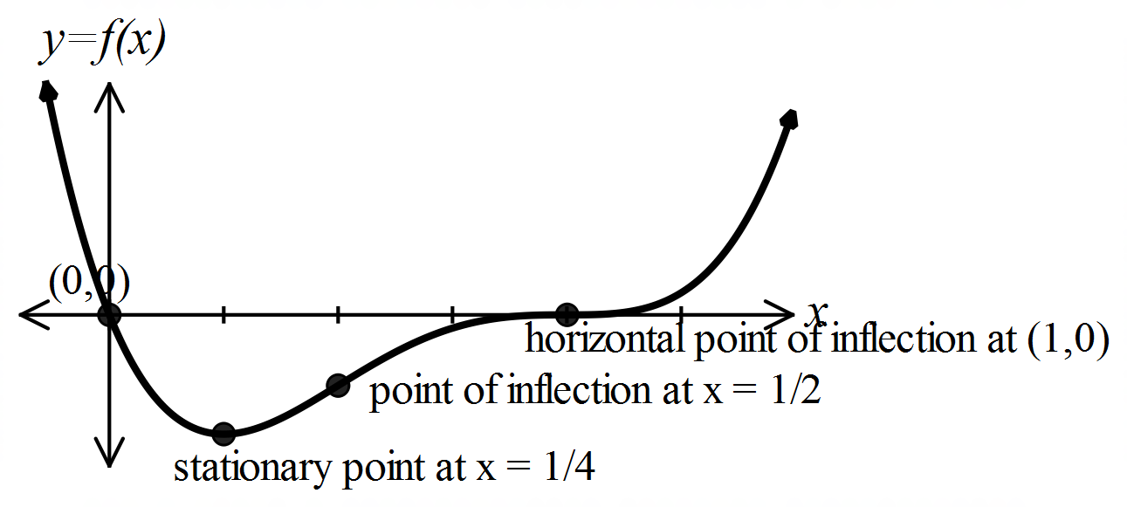

Mathematical behaviours | Marks
- sketch shows and roots  - clearly shows coordinate of minimum turning point  - graphs correct shape and clearly labels points of inflection | 1  1  1

Question 10(a) (1 mark)
Solution
$X$ has a binomial distribution with parameters $n$ and ie
Mathematical behaviours | Marks
- identifies binomial distribution and states parameters | 1

Question 10(b) (1 mark)
Solution
Mathematical behaviours | Marks
- states correct answer | 1

Question 10(c) (3 marks)
Solution
$n=20:$ $P_{1}=P\left(5≤X≤15\right)≅0.988$
$n=1000:$ $P_{1}=P\left(495≤X≤505\right)≅0.272$
$n=10 000:$ $P_{1}=P\left(4995≤X≤5005\right)≅0.088$ (from calculator)
Mathematical behaviours | Marks
- states a probability inequality relevant to one of the values  - calculates one probability correctly  - calculates all probabilities correctly | 1  1  1

Question 10(d) (1 mark)
Solution
$P_{1}→0$ as $n→∞$
Mathematical behaviours | Marks
- obtains correct answer | 1

Question 10(e) (3 marks)
Solution
$n=20:$ $P_{2}=P\left(9.5≤X≤10.5\right)=P(X=10)≅0.176$
$n=200:$ $P_{2}=P\left(95≤X≤105\right)≅$0.563
$n=1000:$ $P_{2}=P\left(475≤X≤525\right)≅0.893$
Mathematical behaviours | Marks
- states probability inequality relevant to  - calculates one probability correctly  - calculates all probabilities correctly | 1  1  1

Question 10(f) (1 mark)
Solution
$P_{2}→1$ as $n→∞$
Mathematical behaviours | Marks
- obtains correct answer | 1

Question 11(a) (1 mark)
Solution
Mathematical behaviours | Mark
- evaluates | 1

Question 11(b) (3 marks)
Solution
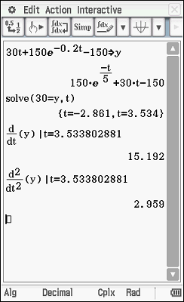

Mathematical behaviours | Marks
- equates and determines time taken to hit the ground  - differentiates to obtain  - calculates the speed | 1  1  1

Question 11(c) (2 marks)
Solution

Since and the ball is speeding up.
Mathematical behaviours | Marks
- differentiates to determine and states  - draws conclusion noting the same sign of both and | 1  1

Question 11(d) (1 mark)
Solution
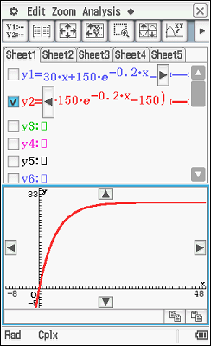
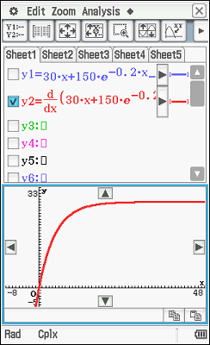

Hence constant speed is attained.
Mathematical behaviours | Marks
- states ie is constant | 1

Question 11(e) (1 mark)
Solution
A restriction on the domain is needed.
ie
Mathematical behaviours | Marks
- states restriction required on the domain | 1

Question 12(a) (2 marks)
Solution
$μ=\frac{49×63.3+38×54.1}{87}=59.28$
Mathematical behaviours | Marks
- uses correct expression  - obtains correct answer | 1  1

Question 12(b) (4 marks)
Solution
If $Y=aX+b,$ then $E\left(Y\right)=aE\left(X\right)+b$and $St.Dev\left(Y\right)=aSt.Dev\left(X\right)$
So $59.28=a×63.3+b$ and $9=a×7.6$
So $a=1.18$ and $b=-15.68$
Mathematical behaviours | Marks
- expresses in terms of  - expresses in terms of  - calculates  - calculates | 1  1  1  1

Question 13(a) (5 marks)
Solution
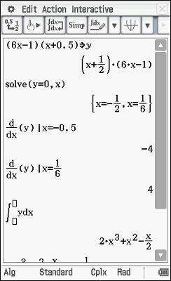
Stationary Points:
i.e.
or
Now
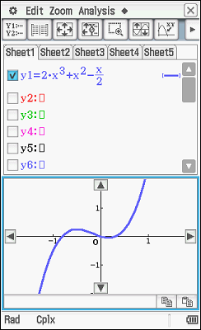
=

Max tp
At , At ,
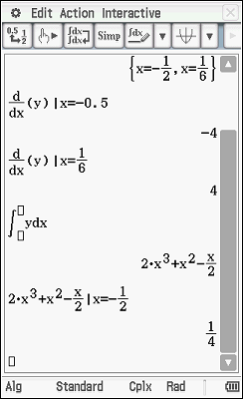
Now
equation of the function is
Mathematical behaviours | Marks
- uses to find stationary points  - substitutes into , and to find which x value gives a local maximum turning point or clearly shows on sketch location of maximum and confirms maximum using 2nd derivative test  - integrates the derivative function correctly  - uses the point to determine the value of c  - states the correct equation of the function | 1  1  1  1  1

Question 13(b) (5 marks)
Solution
(i)

(ii)

Mathematical behaviours | Mark
(i)  - states correct volume to the nearest cubic centimetre  (ii)  - states in terms of  - uses incremental formula to obtain expression for small change in  - substitutes, and  - states the decrease in capacity | 1  1  1  1  1

Question 14(a) (3 marks)
Solution
Total number of cars in sample is $27+13+11+4+14=69$
Proportions of the various colours, and rounded to a whole multiple of $0.05$:

White | Black | Red | Blue | Other
$$\frac{27}{69}≅0.391≅0.4$$ | $$\frac{13}{69}≅0.188≅0.2$$ | $$11/69≅0.159≅0.15$$ | $4/69≅0.0580.0≅0.0$7 | $$14/69≅0.203≅0.2$$

Mathematical behaviours | Marks
- obtains total sample size  - calculates all fractions correctly  - rounds all answers correctly | 1  1  1

Question 14(b) (3 marks)
Solution
Expected number of points per car $=2×0.4+4×0.2+7×0.15+9×0.05+5×0.2=4.1$
So expected number of points per 100 cars $=100×4.1=410$
Mathematical behaviours | Marks
- obtains correct expression for expected value  - calculates expected value (per car) correctly  - obtains correct answer | 1  1  1

Question 14(c) (2 marks)
Solution
Expected number of points per car (by colour)

White | Black | Red | Blue | Other
$$2×0.4=0.8$$ | $$4×0.2=0.8$$ | $$7×0.15=1.05$$ | $$9×0.05=0.45$$ | $$5×0.2=1$$

Since the expected points per car is greatest for Rodney’s red cars, Rodney is most likely to accumulate points fastest.
Mathematical behaviours | Marks
- evaluates expected values correctly  - correct answer | 1  1

Question 14(d) (2 marks)
Solution
$$P={0.4}^{2}+{0.2}^{2}+{0.15}^{2}+{0.05}^{2}+{0.2}^{2}=0.265$$
Mathematical behaviours | Marks
- uses correct formula  - evaluates correctly | 1  1

Question 15(a) (4 marks)
Solution
- none (consecutive selections are not independent so not binomial)
- uniform
- binomial
- binomial
Mathematical behaviours | Marks
i)  - states none  (ii)  - states uniform  (iii)  - states binomial  (iv)  - states binomial | 1  1  1  1

Question 15(b) (4 marks)
Solution
(i) where No, since represents a probability and
probability cannot be negative

 | 4 | 6 | 8 | 10
 | 0.05 | 0.30 | 0.25 | 0.4
(ii)

Yes as and the sum of the probabilities is 1.
Mathematical behaviours | Marks
(i)  - states no  - recognises negative probability  (ii)  - states yes  - states both reasons | 1  1  1  1

Solution
or as required
Mathematical behaviours | Marks
- anti-differentiates to obtain and uses to get  correct expression for .  - anti-differentiates to obtain and uses to get correct  expression for  - states required answer | 1  1  1
Question 16(a) (3 marks)

Solution
Distance travelled =
Mathematical behaviours | Marks
- states the integral of the absolute velocity function from to | 1
Question 16(b) (1 mark)

Question 17(a) (2 marks)
Solution
Define the random variable, as the number of batteries that last for less than 2000 hours. Hence,
Mathematical behaviours | Marks
- recognizes Binomial nature  - obtains correct answer | 1  1

Question 17(b) (2 marks)
Solution
Mathematical behaviours | Marks
- recognizes binomial nature  - obtains correct answer | 1  1

Question 17(c) (2 marks)
Solution
From part (b) we can conclude that there is an 85.6% chance that no more than 15 batteries out of 120 last less than 2000hrs. This would imply that there is only a 14.4% chance that more than 15 out of 120 batteries last less than 2000hrs.
Hence the test does not imply compelling evidence that the manufacturer’s claim is false.
Mathematical behaviours | Marks
- obtains correct answer  - gives valid reason | 1  1

Question 18(a) (3 marks)
Solution
Outcome | Death | Permanent Disability | No payout
Profit | $$-49000$$ | $$-9000$$ | $$1000$$
Probability | $$0.01$$ | $$0.02$$ | $$0.97$$

Mathematical behaviours | Marks
- completes Probability row of table correctly  - completes exactly 2 entries of Profit row of table correctly  - completes table correctly | 1  1  1

Question 18(b) (2 marks)
Solution
$E\left(X\right)=0.01×\left(-49000\right)+0.02×\left(-9000\right)+0.97×1000=300$
Hence the expected profit is $300
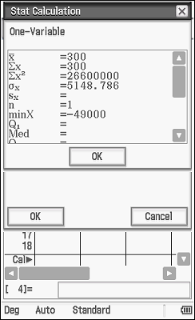
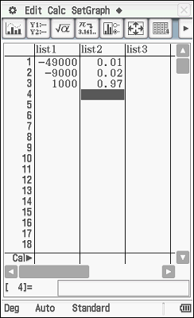

Mathematical behaviours | Marks
- states correct formula for $E(X)$  - obtains correct answer | 1  1

Question 18(c) (3 marks)
Solution
or
Note: CAS screen above shows
Mathematical behaviours | Marks
- demonstrates calculations required to obtain variance  - obtains variance  - obtains standard deviation | 1  1  1

Question 19(a) (1 mark)
Solution
=
Mathematical behaviours | Marks
- states correct answer | 1

Question 19(b) (1 mark)
Solution
Mathematical behaviours | Marks
- states correct answer | 1

Solution
Mathematical behaviours | Marks
- states correct answer | 1
Question 19(c) (1 mark)

Question 19(d) (2 marks)
Solution
Shaded area marked M
Marking key/mathematical behaviours | Marks
- recognises area of rectangle subtract  - states correct answer | 1  1

(i) Correct statement is
(ii) Use CAS and solve for : Solve (
Mathematical behaviours | Marks
(i)  - chooses correct statement  (ii)  - solves for k | 1  1
Question 19(e) (2 marks)

Question 20(a) (3 marks)
Solution
For the circle, For the square,
Hence,
Mathematical behaviours | Mark
- demonstrates that and states expression for the area of the circle  - demonstrates that side length = and states expression for the  area of the square  - concludes formula for | 1  1  1

Question 20(b) (5 marks)
Solution
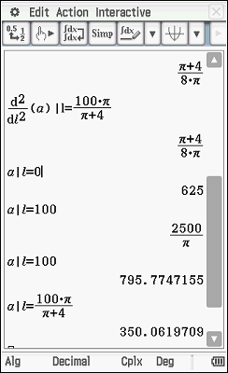
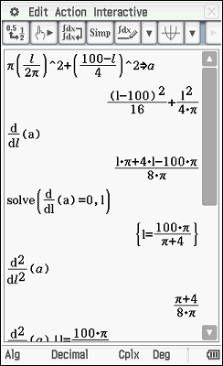
Or, to establish minimum has been achieved at ,
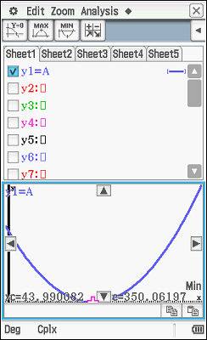
states coefficient of is positive, hence minimum turning point
or demonstrates with graph

Hence the minimum total area is obtained when
Mathematical behaviours | Marks
- determines  - equates and solves  - establishes hence a minimum  - determines for and OR  demonstrates through graph or coefficient of that is a  quadratic with a minimum turning point  - concludes minimum area is when | 1  1  1  1  1

